

Bangladesh Open University

School Of Science and Technology

Bachelor of Science in Computer Science and Technology

**Project: Airplane Management System**

CSE31P8

Submitted by: Supervisor:

#### Sumaiya Islam Samrat Kumar Dey

#### Id: 20-052-801-026 Lecturer (Computer Science)

#### Bangladesh Open Bangladesh Open

#### 

#### University University

#### 

**When I start my project**

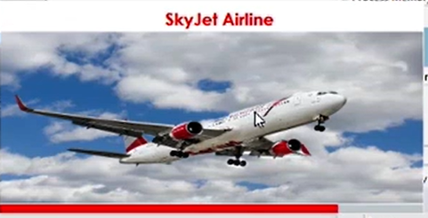

**At first I find a login form**

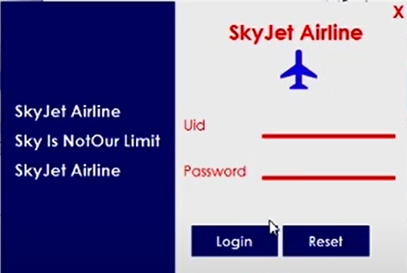

**When I press login without id and password**

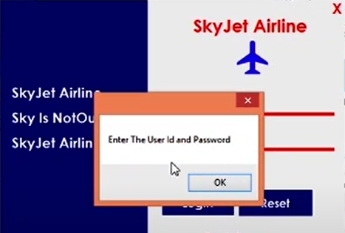

When I enter id and password

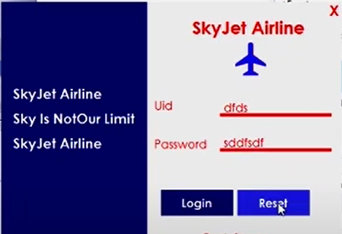

**And then reset**

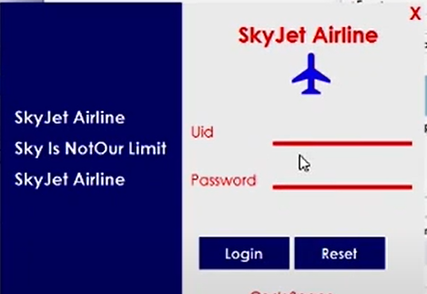

**When I give wrong password**

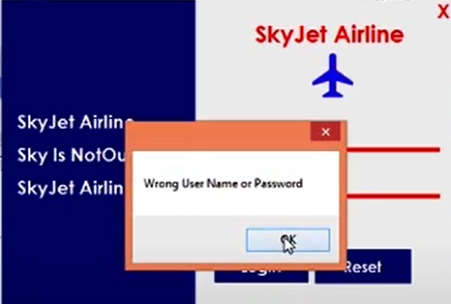

**When I give right id and password and press login**

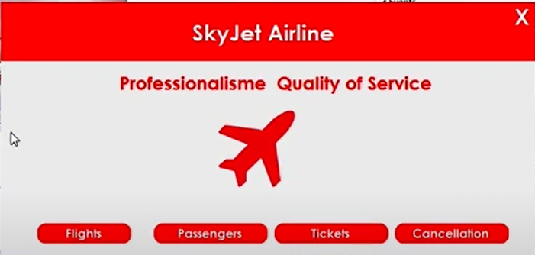

**Then I select Flights and find it**

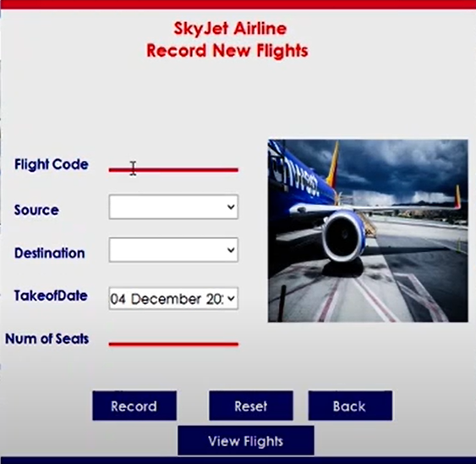

When I fill the form and press record

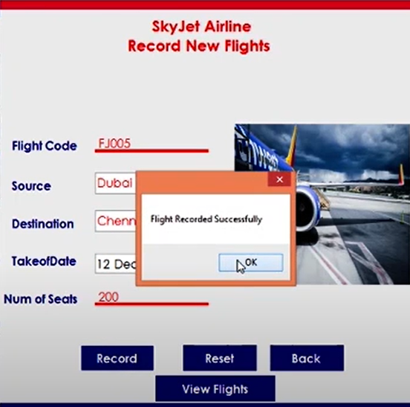

When I press view flight

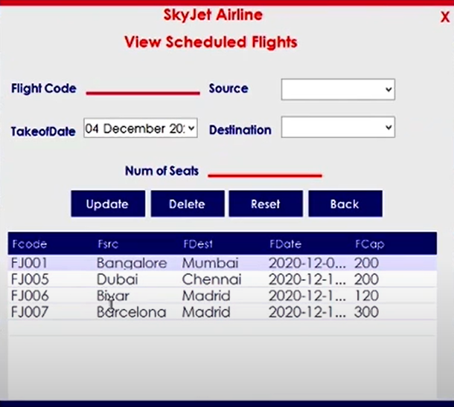

When I want to update

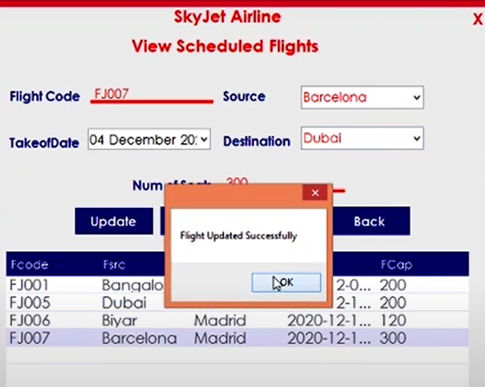

When I press back I find the record page

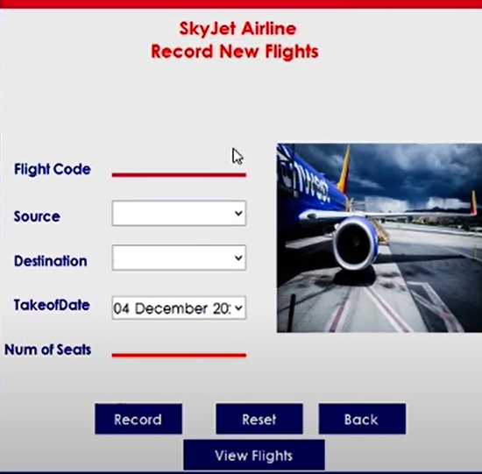

If I press back here I find

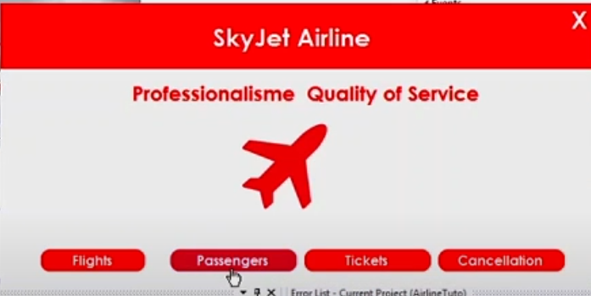

If I press pessenger

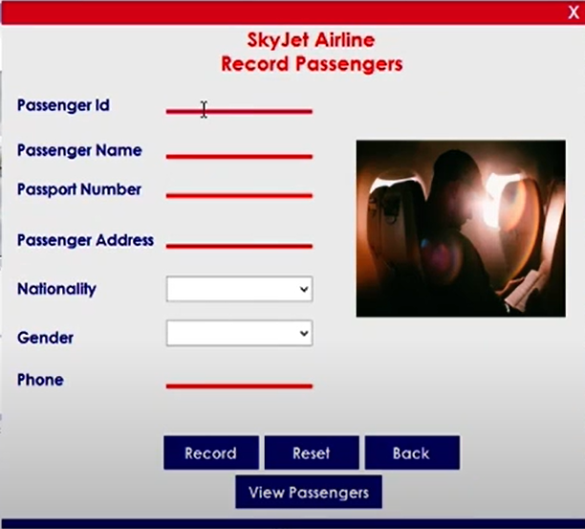

If I want to record a passenger

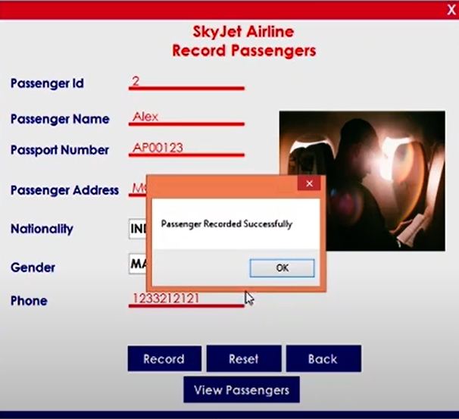

If I press View Passenger

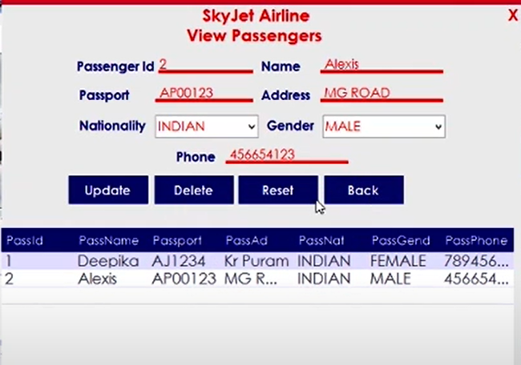

Then I press back and find it

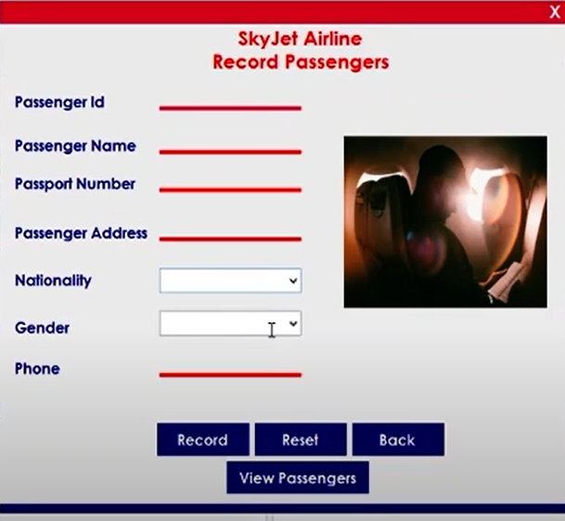

Again I press back and find it

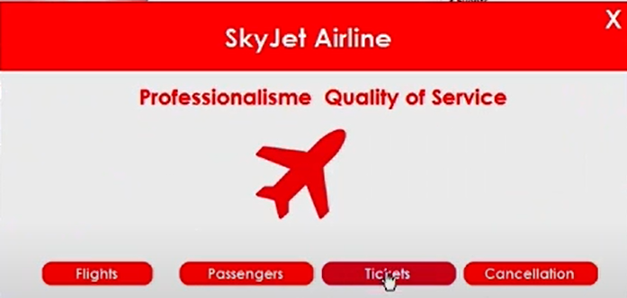

When I press Ticket I see ticket booking page

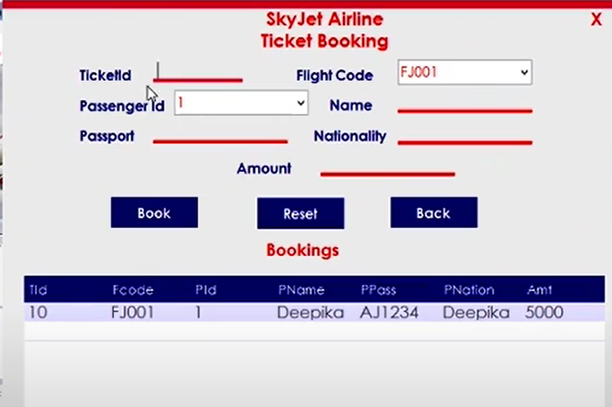

When I fill up the form and press book

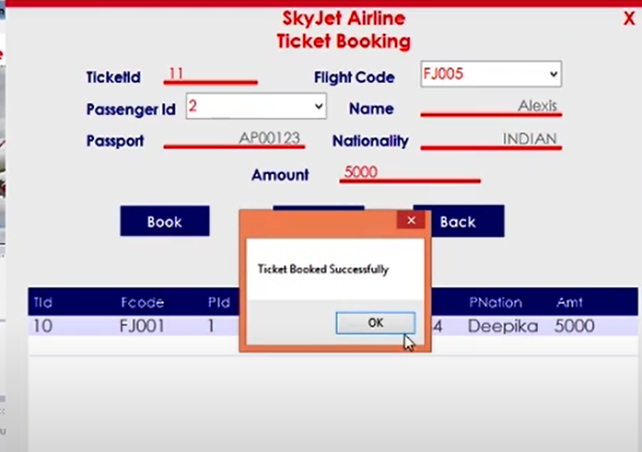

And then press back and find it

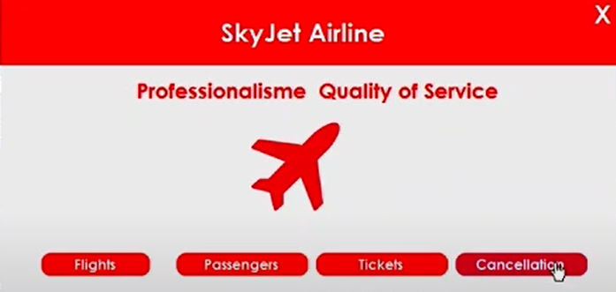

Then I press cancellation and find cancellation page

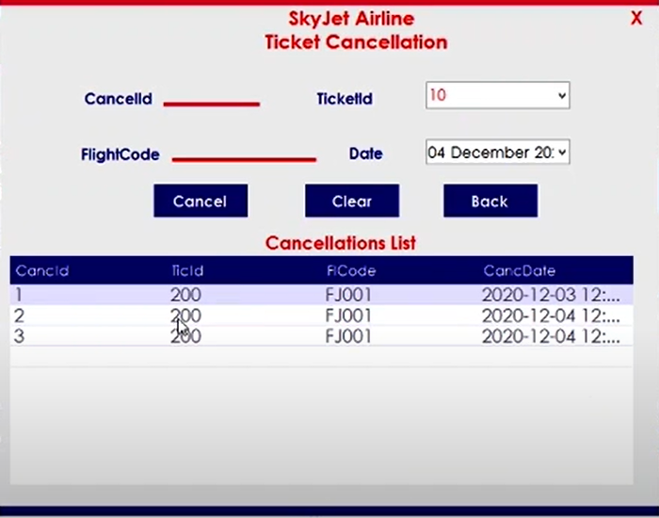

Then I fill the page and press cancel

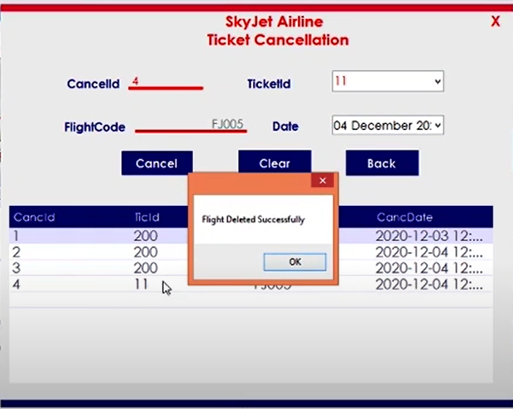

Then I press back

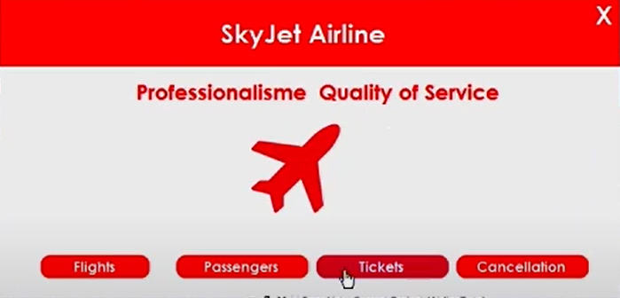

At last press the cross then the project is end